**Resume**

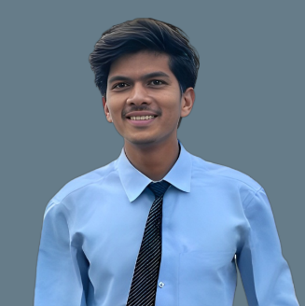

**Mohammad Faizan Shaikh Mannan**

B.E – Information Technology & Engineering

Ph :- 70557864483

Email :- mohdfaizanshaikh136@gmail.com

* **Objective:-**

A believer in excellence, I am eager to learn new skills, to be efficient and productive for the company’s growth, and to broaden my professional skill set.

* **Academic:-** Information Technology

Graduation:-

|  |  |  |  |
| --- | --- | --- | --- |
| Course | University | year | Aggregate |
| III |  | 2021 | 75.40% |
| IV | Sant Gadge Baba university | 2022 |
| V |  | 2022 |
| VI |  | 2023 |

* HSC & SSC :-

My 12th is done in SCC and achieve 50%.

My 10th is done in CBSE and achieve 62.20%.

* Diploma :-

My Diploma is done in IT and achieve 80.45 CGPA.

* Technical Skills:-

C++, Java, Html, CSS, Javascript, SQL

* **Extra curricular activities:-**
* Member of Coding Web Club at College.
* **Strengths:-**
* Good team member.
* Having Supportive nature..
* **Language profile:-**
* English
* Hindi
* **Personal details:-**
* Mother Name: Raziya Bi
* Father Name: Shaikh Mannan
* Address: Near Nagina masjid new town badnera ,Amravati
* Email: mohhdfaizanshaikh136@gmail.com
* Contact: 7057864483
* DOB : 06/11/1999
* **Declaration:-**

All the information Shared in the resume is correct, and I take full responsibility for its correctness.